Elekta Beam Output Adjustment Procedure

# At Elekta console

1. An hour before you calibrate, plug in electrometer using white triax cable. Turn on electrometer.
2. Warm up electrometer.
   1. Zero the electrometer.
   2. Set the bias to -300.
   3. Zero the electrometer once more.

# In Physics

1. Take the pressure using the barometer on the wall.
2. Print a copy of *T:\Physics - T\QA\TG-51 (Output QA)\Datasheets\Elekta\Photons Cylindrical\Elekta Output Adjustment Calculation Spreadsheet.xlsx*.

# In Elekta treatment room

1. Set up per TG-51.
   1. Place indexing bar at location 1 on table.
   2. Put 10 cm of solid water for backscatter, against the indexing bar.
   3. Add the solid water with the hole for the cylindrical ion chamber.
   4. Add solid water to make 10 cm on top, including 1 cm from the block with the hole for the chamber.
   5. Take cap off cylindrical ion chamber and insert into hole.
   6. Attach ion chamber to long, white triax cable from Engineers Room. Tape triax cable to table for stability.
   7. Push the ion chamber box toward solid water to help stabilize ion chamber.
   8. Align solid water block to 100 SSD. Align with x and y lasers.

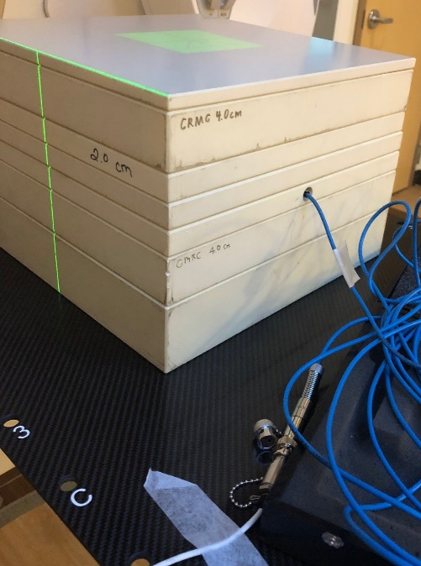

1. Take the temperature.

# At Elekta console

1. Open the most recent copy of *T:\Physics - T\QA\TG-51 (Output QA)\Datasheets\Elekta\Photons Cylindrical\Past Data\ m-d-Y* *TG-51 Elekta[1 or 2] Photons Cylindrical.xlsx* for the machine that you’re calibrating.
2. On each sheet in the spreadsheet that you will be using, fill in the date, your initials, the temperature, and the pressure in the appropriate cells.
3. Save the document as *m-d-Y* *TG-51 Elekta[1 or 2] Photons Cylindrical.xlsx*.
4. Log in to the linac computer in service mode. Username and password are both *service*.
5. Disable all energies that you are calibrating.
   1. Click the *Admin Linac* icon.

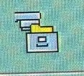

* 1. Click the *Enable/Disable* icon.
  2. Move the appropriate energies to the *Disabled* column.

1. Click the *Service Functions* icon.

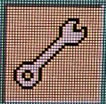

1. Click the *Deliver Quick Beam* icon.

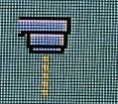

1. On the *Radiation* tab, set the following:
   1. Radiation type: x-rays
   2. Energy: 6 MV
   3. Wedge: out
   4. Beam MU1: 100
   5. Beam MU2: 102
   6. Doserate: 0
2. On the *MLC* tab, if you are calibrating photons, set the field size to 10×10. If you are calibrating electrons, set it to *None*.
3. Warm up the linac.
   1. On the *Radiation* tab, set the Segment 1 MU to 400.
   2. Click *Load*, then *Confirm*.
   3. Zero the electrometer.
   4. When the top horizontal stripe at the bottom left of the linac screen says *Ready to treat*, press the green MV button on the Elekta FKP to deliver beam.

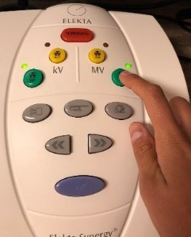

1. Repeat the following for each photon energy that you are calibrating. You may want to shoot two beams and take the average of the electrometer readings.
   1. Fill in the energy in the *Energy* column on the output adjustment worksheet.
   2. In the *TG-51 Pre Adjust Calibration Factor* column, fill in the calibration factor obtained at the last full TG-51 calibration.
   3. Deliver the beam.
      1. On the *Radiation* tab, set the Segment 1 MU to 100.
      2. Click *Load*, then *Confirm*.
      3. Zero the electrometer.
      4. When the top horizontal stripe at the bottom left of the linac screen says *Ready to treat*, press the green MV button on the Elekta FKP to deliver beam.



* + 1. Note the charge reading on the electrometer. Fill in the *Charge* cells in the spreadsheet and the *Pre Adjust Electron Reading* column on the worksheet.
    2. Click the *Calibration* icon.

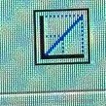

* + 1. Click the *Calculate Reference Dose* icon.
    2. Look at the second row in the *Dose Reference Calculator* window. Enter the first value in the *Segment MU1 (Actual) Prescribed Value* column on the worksheet. Enter the second value in the *Segment MU2 (Actual) Prescribed Value* column.
    3. Multiply the pre-adjust electron reading by the MU1 prescribed value; then divide the product by 1.003. (Hysteresis is 0.003. We divide by 1.003 to allow for down drift.) Fill in this result in the *Actual Measured Dose* column and in the *Measured Dose* field in the linac software. Hit *Enter* on the linac software.
    4. The *Dose Ref 1* and *Dose Ref 2* fields should automatically populate. Click *Set Ref 1* and *Set Ref 2*.
    5. Click *Set(600)*.
    6. Click the *Save* icon.

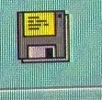

* + 1. Click *Save Energy Cal. Blocks* twice. Close out of *Dose Reference Calibration* windows buy clicking the *X* in the top right corner.
    2. Multiply the pre-adjust electron reading by 100 and divide the result by the actual measured dose. Fill in the result in the *Expected Post Adjust Electron Reading* column.
    3. Note the pink value (MU at Dmax in water) at the bottom of the spreadsheet. Fill in this value in the *TG-51 Post Adjust Calibration Factor* column on the worksheet.
    4. Return to the *Deliver Quick Beam* window to calibrate the next energy.

1. Ensure that all post-adjust calibration factors are within 1 percent of the calibration factor obtained from the last full TG-51 (*TG-51 Pre Adjust Calibration Factor*).
2. Fill in the calibration results in the *Calibration Results* table in the spreadsheet.